030119_GH17&18Analysis_PostStatsConsult

Kelsey Fisher

March 1, 2019

##work directory  
setwd("C:/Users/kefisher/Box Sync/Publications/Monarch Larval Biomass Consumption - GH 2017 & 2018/Analysis_022019")  
##home directory  
#setwd("C:/Users/Kelsey/Box/Publications/Monarch Larval Biomass Consumption - GH 2017 & 2018/Analysis_022019")  
  
library(ggplot2)  
library(emmeans)

### 2017 & 2018 Data

### Days Until Natal Plant Abandonment

Natal<-read.csv("011819_GH17&18_Abandonment.csv")  
  
Natal$Trial=factor(Natal$Trial)  
Natal$Block=factor(Natal$Block)  
Natal$NumPlants=factor(Natal$NumPlants)  
Natal$Year=factor(Natal$Year)  
# Create Year-Block variable with 12 levels  
Natal$YearBlock <- as.numeric(as.factor(paste(Natal$Year, Natal$Block, sep = "-")))  
Natal$YearBlock <- as.factor(Natal$YearBlock)

# Poisson glm

# Poisson glm  
daystomove <- glm(DaysToMove ~ YearBlock + Trial + NumPlants + Trial:NumPlants, data=Natal, family = poisson(link = "log"))  
#not useful, just make sure there isn't a bunch of NA  
summary(daystomove)

##   
## Call:  
## glm(formula = DaysToMove ~ YearBlock + Trial + NumPlants + Trial:NumPlants,   
## family = poisson(link = "log"), data = Natal)  
##   
## Deviance Residuals:   
## Min 1Q Median 3Q Max   
## -2.57783 -0.63945 -0.00046 0.47845 1.84910   
##   
## Coefficients: (1 not defined because of singularities)  
## Estimate Std. Error z value Pr(>|z|)   
## (Intercept) 1.974049 0.158376 12.464 <2e-16 ***  
## YearBlock2 -0.020822 0.110500 -0.188 0.851   
## YearBlock3 -0.068499 0.111037 -0.617 0.537   
## YearBlock4 -0.167431 0.235714 -0.710 0.478   
## YearBlock5 -0.080842 0.266640 -0.303 0.762   
## YearBlock6 -0.059049 0.229692 -0.257 0.797   
## YearBlock7 0.084063 0.244805 0.343 0.731   
## YearBlock8 0.108032 0.272179 0.397 0.691   
## YearBlock9 -0.070800 0.238366 -0.297 0.766   
## YearBlock10 -0.041672 0.321855 -0.129 0.897   
## YearBlock11 0.062455 0.307916 0.203 0.839   
## YearBlock12 -0.020927 0.313513 -0.067 0.947   
## Trial2 -0.147428 0.210852 -0.699 0.484   
## Trial3 -0.091228 0.200769 -0.454 0.650   
## Trial4 0.112490 0.197097 0.571 0.568   
## Trial5 0.235685 0.207095 1.138 0.255   
## Trial6 -0.267341 0.204615 -1.307 0.191   
## Trial7 NA NA NA NA   
## NumPlants3 -0.118419 0.230533 -0.514 0.607   
## NumPlants4 -0.006197 0.237951 -0.026 0.979   
## Trial2:NumPlants3 0.361432 0.330926 1.092 0.275   
## Trial3:NumPlants3 0.084120 0.316534 0.266 0.790   
## Trial4:NumPlants3 -0.063411 0.314081 -0.202 0.840   
## Trial5:NumPlants3 -0.154784 0.300848 -0.514 0.607   
## Trial6:NumPlants3 0.171024 0.280699 0.609 0.542   
## Trial7:NumPlants3 0.140928 0.309891 0.455 0.649   
## Trial2:NumPlants4 0.173828 0.317686 0.547 0.584   
## Trial3:NumPlants4 -0.023419 0.317998 -0.074 0.941   
## Trial4:NumPlants4 -0.296958 0.307418 -0.966 0.334   
## Trial5:NumPlants4 0.053999 0.322506 0.167 0.867   
## Trial6:NumPlants4 0.149311 0.291760 0.512 0.609   
## Trial7:NumPlants4 0.028500 0.310131 0.092 0.927   
## ---  
## Signif. codes: 0 '***' 0.001 '**' 0.01 '*' 0.05 '.' 0.1 ' ' 1  
##   
## (Dispersion parameter for poisson family taken to be 1)  
##   
## Null deviance: 125.83 on 161 degrees of freedom  
## Residual deviance: 107.90 on 131 degrees of freedom  
## AIC: 766.06  
##   
## Number of Fisher Scoring iterations: 4

# Goodness of fit test with Resids  
Resids <- residuals(daystomove, type = "pearson")  
#Change "type" to "deviance" for deviance resids (get the same results)  
plot(fitted(daystomove), Resids,  
 xlab = "estimated mean",  
 ylab = "residual",  
 cex.lab = 1.4,  
 pch = 16, col = 4)  
abline(h = 0, lty = 2) #Resids look okay

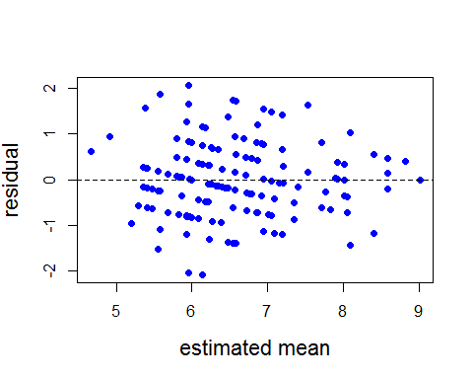

hist(Resids, prob = T)  
lines(density(Resids), col='orange') #Should look like a standard normal - does

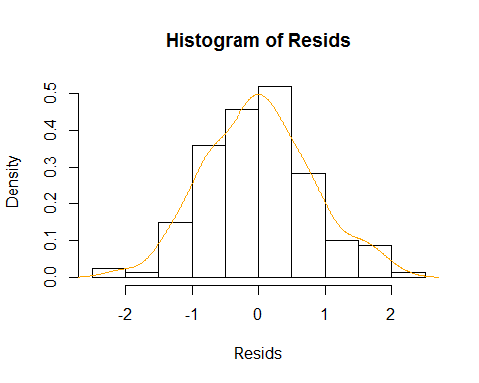

#Using deviance residuals  
#If the p-value is less than 0.05, you have a problem with model fit  
pchisq(deviance(daystomove), df.residual(daystomove), lower.tail = F)

## [1] 0.9304447

#Test for overdispersion  
summary(daystomove)$deviance/summary(daystomove)$df.residual

## [1] 0.8236539

#0.82 underdispersed by a bit - that's okay (inference is conservative)

# Test for significance of NumPlants  
dtm.emm <- emmeans(daystomove, c("NumPlants", "Trial", "YearBlock"), type='response')  
joint_tests(dtm.emm)

## model term df1 df2 F.ratio p.value note  
## NumPlants 2 Inf 0.201 0.8179   
## Trial 5 Inf 1.594 0.1578 e  
## YearBlock 10 Inf 0.351 0.9666 e  
## NumPlants:Trial 12 Inf 0.582 0.8585   
##   
## e: df1 reduced due to non-estimability

#average by number of plants  
library(plyr)  
ddply(Natal,~NumPlants,summarise,mean=mean(DaysToMove),sd=sd(DaysToMove))

## NumPlants mean sd  
## 1 2 6.727273 2.040829  
## 2 3 6.327273 2.055296  
## 3 4 6.615385 2.529464

#Graph for manuscript  
library(lattice)  
library(Rmisc)  
SEDays<- summarySE(Natal, measurevar="DaysToMove", groupvars=c("NumPlants"))  
SEDays

## NumPlants N DaysToMove sd se ci  
## 1 2 55 6.727273 2.040829 0.2751853 0.5517134  
## 2 3 55 6.327273 2.055296 0.2771361 0.5556244  
## 3 4 52 6.615385 2.529464 0.3507736 0.7042074

library(ggplot2)  
ggplot(SEDays, aes(x=NumPlants, y=DaysToMove, width=.6))+  
 geom_bar(stat="identity", color="black",  
 position=position_dodge())+  
 xlab("Number of Plants") +  
 ylab("Days Until Natal Plant Abandonment")+  
 theme_bw()+  
 geom_errorbar(aes(ymin=DaysToMove-sd, ymax=DaysToMove+sd), width=.2,  
 position = position_dodge(.9))+  
 scale_y_continuous(expand=c(0,0), limits=c(0,10.1))+  
 theme(panel.grid.major = element_blank(), panel.grid.minor = element_blank(),  
 panel.background = element_blank(), axis.line = element_line(colour = "black"))+  
 theme(axis.text.x = element_text(size=16))+  
 theme(axis.text.x=element_text(colour="black"))+  
 theme(axis.text.y = element_text(size=16))+  
 theme(axis.text.y=element_text(colour="black"))+  
 theme(axis.title = element_text(size = 15))

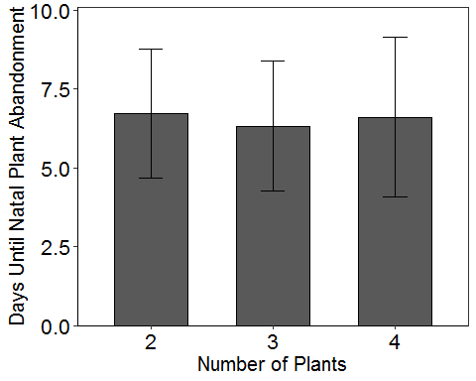

#stats for manuscript  
Days=Natal$DaysToMove  
mean(Days)

## [1] 6.555556

sd(Days)

## [1] 2.206709

max(Days)

## [1] 12

min(Days)

## [1] 1

### Instar at Natal Abandonment

# Poisson glm

# Poisson glm  
instar <- glm(InstarToMove ~ YearBlock + Trial + NumPlants + Trial:NumPlants, data=Natal, family = poisson(link = "log"))  
#not useful, just make sure there isn't a bunch of NA  
summary(instar)

##   
## Call:  
## glm(formula = InstarToMove ~ YearBlock + Trial + NumPlants +   
## Trial:NumPlants, family = poisson(link = "log"), data = Natal)  
##   
## Deviance Residuals:   
## Min 1Q Median 3Q Max   
## -1.85479 -0.29566 0.05465 0.24998 0.72107   
##   
## Coefficients: (1 not defined because of singularities)  
## Estimate Std. Error z value Pr(>|z|)   
## (Intercept) 1.329426 0.212580 6.254 4.01e-10 ***  
## YearBlock2 0.032039 0.143244 0.224 0.823   
## YearBlock3 0.023379 0.141917 0.165 0.869   
## YearBlock4 0.002037 0.308999 0.007 0.995   
## YearBlock5 0.034886 0.348906 0.100 0.920   
## YearBlock6 0.035733 0.303194 0.118 0.906   
## YearBlock7 0.178477 0.322473 0.553 0.580   
## YearBlock8 0.160081 0.355864 0.450 0.653   
## YearBlock9 0.066434 0.312871 0.212 0.832   
## YearBlock10 0.069015 0.413465 0.167 0.867   
## YearBlock11 0.119394 0.401202 0.298 0.766   
## YearBlock12 0.119394 0.401202 0.298 0.766   
## Trial2 -0.036493 0.275500 -0.132 0.895   
## Trial3 0.129613 0.257080 0.504 0.614   
## Trial4 0.142718 0.264030 0.541 0.589   
## Trial5 0.195194 0.270428 0.722 0.470   
## Trial6 -0.194956 0.262483 -0.743 0.458   
## Trial7 NA NA NA NA   
## NumPlants3 0.041021 0.296357 0.138 0.890   
## NumPlants4 0.042913 0.316777 0.135 0.892   
## Trial2:NumPlants3 0.156168 0.427036 0.366 0.715   
## Trial3:NumPlants3 -0.014547 0.392579 -0.037 0.970   
## Trial4:NumPlants3 -0.237758 0.410152 -0.580 0.562   
## Trial5:NumPlants3 -0.202362 0.386772 -0.523 0.601   
## Trial6:NumPlants3 0.024158 0.359295 0.067 0.946   
## Trial7:NumPlants3 -0.048218 0.401680 -0.120 0.904   
## Trial2:NumPlants4 -0.044160 0.422008 -0.105 0.917   
## Trial3:NumPlants4 -0.104372 0.407435 -0.256 0.798   
## Trial4:NumPlants4 -0.234338 0.404568 -0.579 0.562   
## Trial5:NumPlants4 -0.028200 0.429559 -0.066 0.948   
## Trial6:NumPlants4 0.093624 0.382716 0.245 0.807   
## Trial7:NumPlants4 -0.072044 0.410471 -0.176 0.861   
## ---  
## Signif. codes: 0 '***' 0.001 '**' 0.01 '*' 0.05 '.' 0.1 ' ' 1  
##   
## (Dispersion parameter for poisson family taken to be 1)  
##   
## Null deviance: 36.725 on 161 degrees of freedom  
## Residual deviance: 30.939 on 131 degrees of freedom  
## AIC: 616.29  
##   
## Number of Fisher Scoring iterations: 4

# Goodness of fit test with Resids  
Resids <- residuals(instar, type = "pearson")  
#Change "type" to "deviance" for deviance resids (get the same results)  
plot(fitted(instar), Resids,  
 xlab = "estimated mean",  
 ylab = "residual",  
 cex.lab = 1.4,  
 pch = 16, col = 4)  
abline(h = 0, lty = 2) #Resids look okay

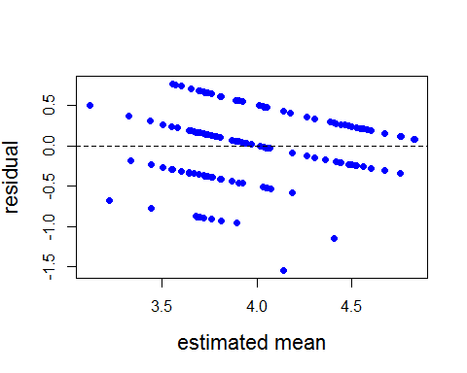

hist(Resids, prob = T)  
lines(density(Resids), col='orange') #Should look like a standard normal - does

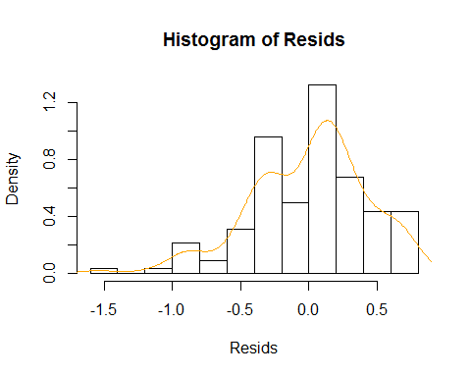

#Using deviance residuals  
#If the p-value is less than 0.05, you have a problem with model fit  
pchisq(deviance(instar), df.residual(instar), lower.tail = F)

## [1] 1

#Test for overdispersion  
summary(instar)$deviance/summary(instar)$df.residual

## [1] 0.2361765

#0.82 underdispersed by a bit - that's okay (inference is conservative)

# Test for significance of NumPlants  
dtm.emm <- emmeans(instar, c("NumPlants", "Trial", "YearBlock"), type='response')  
joint_tests(dtm.emm)

## model term df1 df2 F.ratio p.value note  
## NumPlants 2 Inf 0.008 0.9921   
## Trial 5 Inf 0.591 0.7067 e  
## YearBlock 10 Inf 0.093 0.9999 e  
## NumPlants:Trial 12 Inf 0.194 0.9987   
##   
## e: df1 reduced due to non-estimability

#average by number of plants  
library(plyr)  
ddply(Natal,~NumPlants,summarise,mean=mean(InstarToMove),sd=sd(InstarToMove))

## NumPlants mean sd  
## 1 2 4.036364 0.8598802  
## 2 3 3.945455 0.8480518  
## 3 4 3.942308 1.0368403

#Graph for manuscript  
library(lattice)  
library(Rmisc)  
SEInstar<- summarySE(Natal, measurevar="InstarToMove", groupvars=c("NumPlants"))  
SEInstar

## NumPlants N InstarToMove sd se ci  
## 1 2 55 4.036364 0.8598802 0.1159462 0.2324582  
## 2 3 55 3.945455 0.8480518 0.1143513 0.2292605  
## 3 4 52 3.942308 1.0368403 0.1437839 0.2886582

library(ggplot2)  
ggplot(SEInstar, aes(x=NumPlants, y=InstarToMove, width=.6))+  
 geom_bar(stat="identity", color="black",  
 position=position_dodge())+  
 xlab("Number of Plants") +  
 ylab("Instar at Natal Plant Abandonment")+  
 theme_bw()+  
 geom_errorbar(aes(ymin=InstarToMove-sd, ymax=InstarToMove+sd), width=.2,  
 position = position_dodge(.9))+  
 scale_y_continuous(expand=c(0,0), limits=c(0,5.1))+  
 theme(panel.grid.major = element_blank(), panel.grid.minor = element_blank(),  
 panel.background = element_blank(), axis.line = element_line(colour = "black"))+  
 theme(axis.text.x = element_text(size=16))+  
 theme(axis.text.x=element_text(colour="black"))+  
 theme(axis.text.y = element_text(size=16))+  
 theme(axis.text.y=element_text(colour="black"))+  
 theme(axis.title = element_text(size = 15))

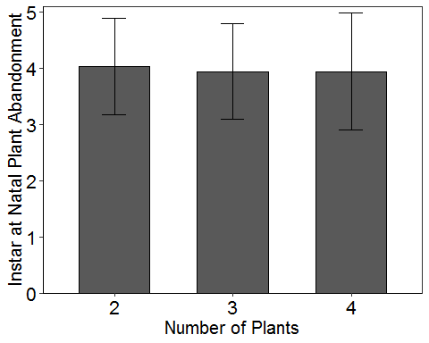

#stats for manuscript  
Instar=Natal$InstarToMove  
mean(Instar)

## [1] 3.975309

sd(Instar)

## [1] 0.9119675

max(Instar)

## [1] 5

min(Instar)

## [1] 1

getmode <- function(Instar) {  
 uniqv <- unique(Instar)  
 uniqv[which.max(tabulate(match(Instar, uniqv)))]  
}  
  
result<-getmode(Instar)  
print(result)

## [1] 4

### Plant Rank at Abandonment

Rank<-read.csv("011819_GH18_PlantRank_NatalAbandonment.csv")

head(Rank)

## Year Trial ID Block NumPlants PlantRank  
## 1 2018 5 1 1 2 4  
## 2 2018 5 2 1 4 2  
## 3 2018 5 6 1 2 4  
## 4 2018 5 10 2 3 3  
## 5 2018 5 11 2 4 3  
## 6 2018 5 17 2 2 2

Rank$Trial=factor(Rank$Trial)  
Rank$Block=factor(Rank$Block)  
Rank$NumPlants=factor(Rank$NumPlants)  
Rank$Year=factor(Rank$Year)  
# Create Year-Block variable with 12 levels  
Rank$YearBlock <- as.numeric(as.factor(paste(Rank$Year, Rank$Block, sep = "-")))  
Rank$YearBlock <- as.factor(Rank$YearBlock)

# Poisson glm  
rank <- glm(PlantRank ~ YearBlock + Trial + NumPlants + Trial:NumPlants, data=Rank, family = poisson(link = "log"))  
#not useful, just make sure there isn't a bunch of NA  
summary(rank)

##   
## Call:  
## glm(formula = PlantRank ~ YearBlock + Trial + NumPlants + Trial:NumPlants,   
## family = poisson(link = "log"), data = Rank)  
##   
## Deviance Residuals:   
## Min 1Q Median 3Q Max   
## -2.2043 -0.6180 0.1525 0.5361 1.5351   
##   
## Coefficients:  
## Estimate Std. Error z value Pr(>|z|)   
## (Intercept) 1.04218 0.29058 3.587 0.000335 ***  
## YearBlock2 0.07005 0.31497 0.222 0.823993   
## YearBlock3 -0.15456 0.24121 -0.641 0.521680   
## YearBlock4 -0.49723 0.30913 -1.608 0.107729   
## YearBlock5 -0.43465 0.32966 -1.318 0.187343   
## YearBlock6 -0.26656 0.28947 -0.921 0.357135   
## YearBlock7 -0.04462 0.36365 -0.123 0.902354   
## YearBlock8 -0.26048 0.38706 -0.673 0.500965   
## YearBlock9 -0.48362 0.41811 -1.157 0.247396   
## Trial6 0.24604 0.33387 0.737 0.461156   
## Trial7 0.02394 0.35856 0.067 0.946778   
## NumPlants3 -0.19553 0.47735 -0.410 0.682094   
## NumPlants4 -0.03752 0.43594 -0.086 0.931404   
## Trial6:NumPlants3 0.10795 0.52190 0.207 0.836141   
## Trial7:NumPlants3 -0.05419 0.60982 -0.089 0.929189   
## Trial6:NumPlants4 -0.25573 0.51128 -0.500 0.616948   
## Trial7:NumPlants4 -0.36733 0.57159 -0.643 0.520449   
## ---  
## Signif. codes: 0 '***' 0.001 '**' 0.01 '*' 0.05 '.' 0.1 ' ' 1  
##   
## (Dispersion parameter for poisson family taken to be 1)  
##   
## Null deviance: 88.345 on 77 degrees of freedom  
## Residual deviance: 77.592 on 61 degrees of freedom  
## AIC: 298.34  
##   
## Number of Fisher Scoring iterations: 5

# Goodness of fit test with Resids  
Resids <- residuals(rank, type = "pearson")  
#Change "type" to "deviance" for deviance resids (get the same results)  
plot(fitted(rank), Resids,  
 xlab = "estimated mean",  
 ylab = "residual",  
 cex.lab = 1.4,  
 pch = 16, col = 4)  
abline(h = 0, lty = 2) #Resids look okay

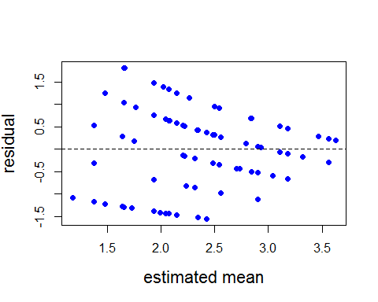

hist(Resids, prob = T)  
lines(density(Resids), col='orange') #Should look like a standard normal - does

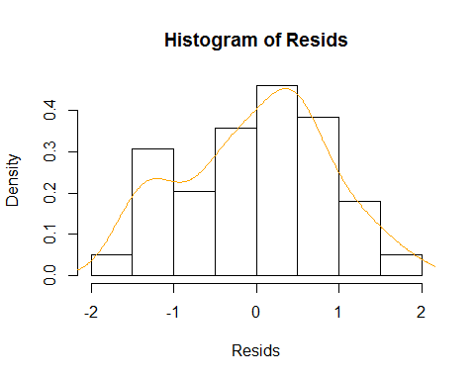

#Using deviance residuals  
#If the p-value is less than 0.05, you have a problem with model fit  
pchisq(deviance(rank), df.residual(rank), lower.tail = F)

## [1] 0.07446492

#Test for overdispersion  
summary(rank)$deviance/summary(rank)$df.residual

## [1] 1.271998

### 1.27 is overdispersed....

### Only 2017 Data

### Days to Pupation

GH17<- read.csv("012119_GH2017_ForAnalysis.csv")

head(GH17)

## Year Trial ID Block NumPlants NeoToAdult PDay PWeight PDuration  
## 1 2017 1 1 1 4 24 13 1.55 11  
## 2 2017 1 2 1 3 21 11 1.31 10  
## 3 2017 1 3 1 2 24 13 1.07 12  
## 4 2017 1 4 1 3 22 11 1.15 11  
## 5 2017 1 5 1 4 24 14 1.13 10  
## 6 2017 1 9 1 2 24 13 1.32 11  
## InstarToMove DaysToMove TimesMoved Move1st Move2nd Move3rd Move4th  
## 1 4 7 5 0 0 0 2  
## 2 4 7 3 0 0 0 2  
## 3 4 8 4 0 0 0 1  
## 4 4 6 4 0 0 0 1  
## 5 4 7 6 0 0 0 2  
## 6 4 7 4 0 0 0 1  
## Move5th PlantAbandonment Abandon1st Abandon2nd Abandon3rd Abandon4th  
## 1 3 4 0 0 0 2  
## 2 1 2 0 0 0 1  
## 3 3 3 0 0 0 1  
## 4 3 3 0 0 0 1  
## 5 4 5 0 0 0 2  
## 6 3 3 0 0 0 1  
## Abandon5th NumPlantsVisited PercPlantsVisited ObsOnPlant ObsOnCage  
## 1 2 4 100.00000 22 3  
## 2 1 1 33.33333 20 3  
## 3 2 2 100.00000 23 3  
## 4 2 2 66.66667 18 5  
## 5 3 4 100.00000 26 3  
## 6 2 2 100.00000 20 6

GH17$Trial=factor(GH17$Trial)  
GH17$Block=factor(GH17$Block)  
GH17$NumPlants=factor(GH17$NumPlants)  
GH17$Year=factor(GH17$Year)  
# Create Year-Block variable with 12 levels  
GH17$YearBlock <- as.numeric(as.factor(paste(GH17$Year, GH17$Block, sep = "-")))  
GH17$YearBlock <- as.factor(GH17$YearBlock)

# Poisson glm

# Poisson glm  
pday <- glm(PDay ~ YearBlock + Trial + NumPlants + Trial:NumPlants, data=GH17, family = poisson(link = "log"))  
#not useful, just make sure there isn't a bunch of NA  
summary(pday)

##   
## Call:  
## glm(formula = PDay ~ YearBlock + Trial + NumPlants + Trial:NumPlants,   
## family = poisson(link = "log"), data = GH17)  
##   
## Deviance Residuals:   
## Min 1Q Median 3Q Max   
## -0.71900 -0.22857 -0.03102 0.15237 0.99760   
##   
## Coefficients:  
## Estimate Std. Error z value Pr(>|z|)   
## (Intercept) 2.587855 0.116534 22.207 <2e-16 ***  
## YearBlock2 -0.006758 0.083641 -0.081 0.936   
## YearBlock3 -0.032075 0.083537 -0.384 0.701   
## Trial2 -0.123743 0.152815 -0.810 0.418   
## Trial3 -0.246964 0.152414 -1.620 0.105   
## Trial4 -0.034125 0.149166 -0.229 0.819   
## NumPlants3 -0.072347 0.165935 -0.436 0.663   
## NumPlants4 -0.013284 0.174304 -0.076 0.939   
## Trial2:NumPlants3 0.123382 0.245891 0.502 0.616   
## Trial3:NumPlants3 0.046891 0.237971 0.197 0.844   
## Trial4:NumPlants3 0.071578 0.229934 0.311 0.756   
## Trial2:NumPlants4 0.021958 0.234953 0.093 0.926   
## Trial3:NumPlants4 -0.008471 0.240377 -0.035 0.972   
## Trial4:NumPlants4 -0.099848 0.227352 -0.439 0.661   
## ---  
## Signif. codes: 0 '***' 0.001 '**' 0.01 '*' 0.05 '.' 0.1 ' ' 1  
##   
## (Dispersion parameter for poisson family taken to be 1)  
##   
## Null deviance: 16.9732 on 76 degrees of freedom  
## Residual deviance: 8.8122 on 63 degrees of freedom  
## AIC: 367.71  
##   
## Number of Fisher Scoring iterations: 4

# Goodness of fit test with Resids  
Resids <- residuals(pday, type = "pearson")  
#Change "type" to "deviance" for deviance resids (get the same results)  
plot(fitted(pday), Resids,  
 xlab = "estimated mean",  
 ylab = "residual",  
 cex.lab = 1.4,  
 pch = 16, col = 4)  
abline(h = 0, lty = 2) #Resids look okay

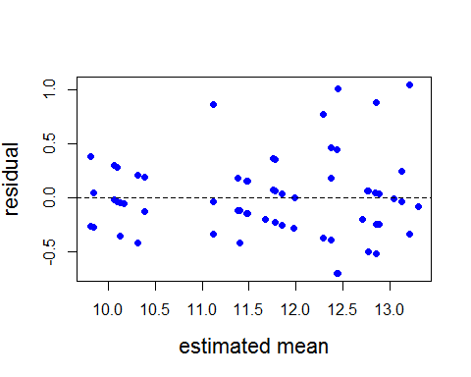

hist(Resids, prob = T)  
lines(density(Resids), col='orange') #Should look like a standard normal - does

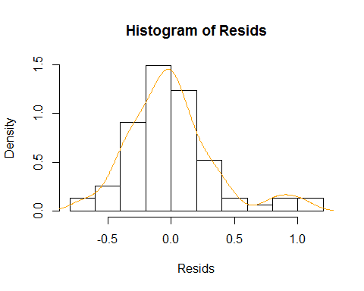

#Using deviance residuals  
#If the p-value is less than 0.05, you have a problem with model fit  
pchisq(deviance(pday), df.residual(pday), lower.tail = F)

## [1] 1

#Test for overdispersion  
summary(pday)$deviance/summary(pday)$df.residual

## [1] 0.1398758

#0.82 underdispersed by a bit - that's okay (inference is conservative)

# Test for significance of NumPlants  
dtm.emm <- emmeans(pday, c("NumPlants", "Trial", "YearBlock"), type='response')  
joint_tests(dtm.emm)

## model term df1 df2 F.ratio p.value  
## NumPlants 2 Inf 0.096 0.9080   
## Trial 3 Inf 2.158 0.0907   
## YearBlock 2 Inf 0.083 0.9205   
## NumPlants:Trial 6 Inf 0.134 0.9920

#average by number of plants  
library(plyr)  
ddply(GH17,~NumPlants,summarise,mean=mean(PDay),sd=sd(PDay))

## NumPlants mean sd  
## 1 2 11.86207 1.884602  
## 2 3 11.71429 1.677583  
## 3 4 11.33333 1.300887

#Graph for manuscript  
library(lattice)  
library(Rmisc)  
SEPDay<- summarySE(GH17, measurevar="PDay", groupvars=c("NumPlants"))  
SEPDay

## NumPlants N PDay sd se ci  
## 1 2 29 11.86207 1.884602 0.3499618 0.7168642  
## 2 3 21 11.71429 1.677583 0.3660787 0.7636268  
## 3 4 27 11.33333 1.300887 0.2503559 0.5146139

library(ggplot2)  
ggplot(SEPDay, aes(x=NumPlants, y=PDay, width=.6))+  
 geom_bar(stat="identity", color="black",  
 position=position_dodge())+  
 xlab("Number of Plants") +  
 ylab("Day of Pupal Formation")+  
 theme_bw()+  
 geom_errorbar(aes(ymin=PDay-sd, ymax=PDay+sd), width=.2,  
 position = position_dodge(.9))+  
 scale_y_continuous(expand=c(0,0), limits=c(0,15.1))+  
 theme(panel.grid.major = element_blank(), panel.grid.minor = element_blank(),  
 panel.background = element_blank(), axis.line = element_line(colour = "black"))+  
 theme(axis.text.x = element_text(size=16))+  
 theme(axis.text.x=element_text(colour="black"))+  
 theme(axis.text.y = element_text(size=16))+  
 theme(axis.text.y=element_text(colour="black"))+  
 theme(axis.title = element_text(size = 15))

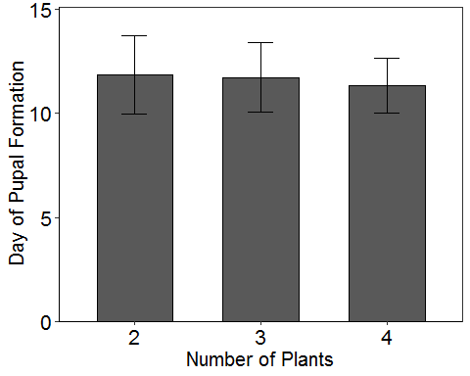

#stats for manuscript  
PDay=GH17$PDay  
mean(PDay)

## [1] 11.63636

sd(PDay)

## [1] 1.637626

max(PDay)

## [1] 17

min(PDay)

## [1] 9

getmode <- function(PDay) {  
 uniqv <- unique(PDay)  
 uniqv[which.max(tabulate(match(PDay, uniqv)))]  
}  
  
result<-getmode(PDay)  
print(result)

## [1] 11

### Pupal Weight

Weight<- read.csv("012119_GH2017_ForAnalysis_pweight.csv", header=TRUE)

Weight$Trial=factor(Weight$Trial)  
Weight$Block=factor(Weight$Block)  
Weight$NumPlants=factor(Weight$NumPlants)  
Weight$Year=factor(Weight$Year)  
# Create Year-Block variable with 12 levels  
Weight$YearBlock <- as.numeric(as.factor(paste(Weight$Year, Weight$Block, sep = "-")))  
Weight$YearBlock <- as.factor(Weight$YearBlock)  
Weight$PWeight <- as.numeric(Weight$PWeight)

# Poisson glm

# Poisson glm  
pweight <- glm(PWeight ~ YearBlock + Trial + NumPlants + Trial:NumPlants, data=Weight, family = poisson(link = "log"))

## Warning in dpois(y, mu, log = TRUE): non-integer x = 1.550000

## Warning in dpois(y, mu, log = TRUE): non-integer x = 1.310000

## Warning in dpois(y, mu, log = TRUE): non-integer x = 1.070000

## Warning in dpois(y, mu, log = TRUE): non-integer x = 1.150000

## Warning in dpois(y, mu, log = TRUE): non-integer x = 1.130000

## Warning in dpois(y, mu, log = TRUE): non-integer x = 1.320000

## Warning in dpois(y, mu, log = TRUE): non-integer x = 1.100000

## Warning in dpois(y, mu, log = TRUE): non-integer x = 1.380000

## Warning in dpois(y, mu, log = TRUE): non-integer x = 1.290000

## Warning in dpois(y, mu, log = TRUE): non-integer x = 1.460000

## Warning in dpois(y, mu, log = TRUE): non-integer x = 1.420000

## Warning in dpois(y, mu, log = TRUE): non-integer x = 1.280000

## Warning in dpois(y, mu, log = TRUE): non-integer x = 1.460000

## Warning in dpois(y, mu, log = TRUE): non-integer x = 1.410000

## Warning in dpois(y, mu, log = TRUE): non-integer x = 1.310000

## Warning in dpois(y, mu, log = TRUE): non-integer x = 1.350000

## Warning in dpois(y, mu, log = TRUE): non-integer x = 1.360000

## Warning in dpois(y, mu, log = TRUE): non-integer x = 1.380000

## Warning in dpois(y, mu, log = TRUE): non-integer x = 1.520000

## Warning in dpois(y, mu, log = TRUE): non-integer x = 1.440000

## Warning in dpois(y, mu, log = TRUE): non-integer x = 1.470000

## Warning in dpois(y, mu, log = TRUE): non-integer x = 1.190000

## Warning in dpois(y, mu, log = TRUE): non-integer x = 1.380000

## Warning in dpois(y, mu, log = TRUE): non-integer x = 1.300000

## Warning in dpois(y, mu, log = TRUE): non-integer x = 1.260000

## Warning in dpois(y, mu, log = TRUE): non-integer x = 1.290000

## Warning in dpois(y, mu, log = TRUE): non-integer x = 1.270000

## Warning in dpois(y, mu, log = TRUE): non-integer x = 1.470000

## Warning in dpois(y, mu, log = TRUE): non-integer x = 1.520000

## Warning in dpois(y, mu, log = TRUE): non-integer x = 1.230000

## Warning in dpois(y, mu, log = TRUE): non-integer x = 1.600000

## Warning in dpois(y, mu, log = TRUE): non-integer x = 1.390000

## Warning in dpois(y, mu, log = TRUE): non-integer x = 1.280000

## Warning in dpois(y, mu, log = TRUE): non-integer x = 1.300000

## Warning in dpois(y, mu, log = TRUE): non-integer x = 1.390000

## Warning in dpois(y, mu, log = TRUE): non-integer x = 1.500000

## Warning in dpois(y, mu, log = TRUE): non-integer x = 1.290000

## Warning in dpois(y, mu, log = TRUE): non-integer x = 1.170000

## Warning in dpois(y, mu, log = TRUE): non-integer x = 1.290000

## Warning in dpois(y, mu, log = TRUE): non-integer x = 1.460000

## Warning in dpois(y, mu, log = TRUE): non-integer x = 1.480000

## Warning in dpois(y, mu, log = TRUE): non-integer x = 1.140000

## Warning in dpois(y, mu, log = TRUE): non-integer x = 1.420000

## Warning in dpois(y, mu, log = TRUE): non-integer x = 1.540000

## Warning in dpois(y, mu, log = TRUE): non-integer x = 1.230000

## Warning in dpois(y, mu, log = TRUE): non-integer x = 1.460000

## Warning in dpois(y, mu, log = TRUE): non-integer x = 1.300000

## Warning in dpois(y, mu, log = TRUE): non-integer x = 1.370000

## Warning in dpois(y, mu, log = TRUE): non-integer x = 1.550000

## Warning in dpois(y, mu, log = TRUE): non-integer x = 1.020000

## Warning in dpois(y, mu, log = TRUE): non-integer x = 1.410000

## Warning in dpois(y, mu, log = TRUE): non-integer x = 1.320000

## Warning in dpois(y, mu, log = TRUE): non-integer x = 1.270000

## Warning in dpois(y, mu, log = TRUE): non-integer x = 1.090000

## Warning in dpois(y, mu, log = TRUE): non-integer x = 0.870000

## Warning in dpois(y, mu, log = TRUE): non-integer x = 1.130000

## Warning in dpois(y, mu, log = TRUE): non-integer x = 1.270000

## Warning in dpois(y, mu, log = TRUE): non-integer x = 0.920000

## Warning in dpois(y, mu, log = TRUE): non-integer x = 0.740000

## Warning in dpois(y, mu, log = TRUE): non-integer x = 0.760000

## Warning in dpois(y, mu, log = TRUE): non-integer x = 0.900000

## Warning in dpois(y, mu, log = TRUE): non-integer x = 1.350000

## Warning in dpois(y, mu, log = TRUE): non-integer x = 1.290000  
  
## Warning in dpois(y, mu, log = TRUE): non-integer x = 1.290000  
  
## Warning in dpois(y, mu, log = TRUE): non-integer x = 1.290000

## Warning in dpois(y, mu, log = TRUE): non-integer x = 1.260000

## Warning in dpois(y, mu, log = TRUE): non-integer x = 1.610000

## Warning in dpois(y, mu, log = TRUE): non-integer x = 1.480000

## Warning in dpois(y, mu, log = TRUE): non-integer x = 1.530000

## Warning in dpois(y, mu, log = TRUE): non-integer x = 1.150000

## Warning in dpois(y, mu, log = TRUE): non-integer x = 1.200000

## Warning in dpois(y, mu, log = TRUE): non-integer x = 1.180000

## Warning in dpois(y, mu, log = TRUE): non-integer x = 1.540000

## Warning in dpois(y, mu, log = TRUE): non-integer x = 0.850000

#not useful, just make sure there isn't a bunch of NA  
summary(pweight)

##   
## Call:  
## glm(formula = PWeight ~ YearBlock + Trial + NumPlants + Trial:NumPlants,   
## family = poisson(link = "log"), data = Weight)  
##   
## Deviance Residuals:   
## Min 1Q Median 3Q Max   
## -0.31357 -0.08726 0.02809 0.07158 0.53754   
##   
## Coefficients:  
## Estimate Std. Error z value Pr(>|z|)  
## (Intercept) 0.228919 0.388264 0.590 0.555  
## YearBlock2 0.032988 0.258264 0.128 0.898  
## YearBlock3 0.073667 0.251079 0.293 0.769  
## Trial2 0.074210 0.479074 0.155 0.877  
## Trial3 -0.001976 0.473571 -0.004 0.997  
## Trial4 -0.241459 0.518236 -0.466 0.641  
## NumPlants3 0.016639 0.528728 0.031 0.975  
## NumPlants4 0.004395 0.567371 0.008 0.994  
## Trial2:NumPlants3 -0.065481 0.755954 -0.087 0.931  
## Trial3:NumPlants3 -0.059115 0.714628 -0.083 0.934  
## Trial4:NumPlants3 0.174990 0.748310 0.234 0.815  
## Trial2:NumPlants4 -0.035614 0.727647 -0.049 0.961  
## Trial3:NumPlants4 0.081276 0.724078 0.112 0.911  
## Trial4:NumPlants4 0.180958 0.744522 0.243 0.808  
##   
## (Dispersion parameter for poisson family taken to be 1)  
##   
## Null deviance: 2.3334 on 75 degrees of freedom  
## Residual deviance: 1.5548 on 62 degrees of freedom  
## AIC: Inf  
##   
## Number of Fisher Scoring iterations: 4

# Goodness of fit test with Resids  
Resids <- residuals(pweight, type = "pearson")  
#Change "type" to "deviance" for deviance resids (get the same results)  
plot(fitted(pweight), Resids,  
 xlab = "estimated mean",  
 ylab = "residual",  
 cex.lab = 1.4,  
 pch = 16, col = 4)  
abline(h = 0, lty = 2) #Resids look okay

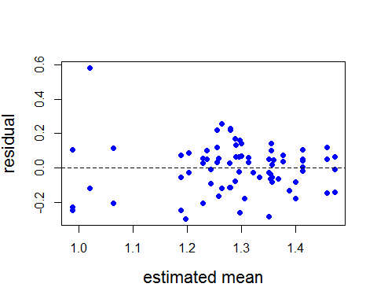

hist(Resids, prob = T)  
lines(density(Resids), col='orange') #Should look like a standard normal - does

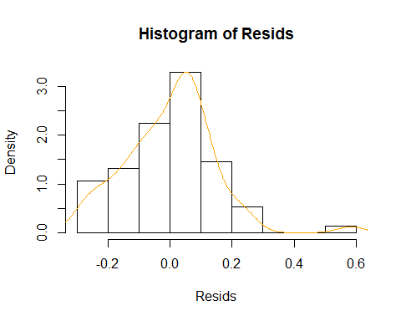

#Using deviance residuals  
#If the p-value is less than 0.05, you have a problem with model fit  
pchisq(deviance(pweight), df.residual(pweight), lower.tail = F)

## [1] 1

#Test for overdispersion  
summary(pweight)$deviance/summary(pweight)$df.residual

## [1] 0.02507775

#0.82 underdispersed by a bit - that's okay (inference is conservative)

# Test for significance of NumPlants  
dtm.emm <- emmeans(pweight, c("NumPlants", "Trial", "YearBlock"), type='response')  
joint_tests(dtm.emm)

## model term df1 df2 F.ratio p.value  
## NumPlants 2 Inf 0.031 0.9693   
## Trial 3 Inf 0.123 0.9466   
## YearBlock 2 Inf 0.044 0.9573   
## NumPlants:Trial 6 Inf 0.033 0.9998

#average by number of plants  
library(plyr)  
ddply(Weight,~NumPlants,summarise,mean=mean(PWeight),sd=sd(PWeight))

## NumPlants mean sd  
## 1 2 1.258571 0.2471874  
## 2 3 1.280476 0.1354428  
## 3 4 1.326667 0.1713072

#Graph for manuscript  
library(lattice)  
library(Rmisc)  
SEPWeight<- summarySE(Weight, measurevar="PWeight", groupvars=c("NumPlants"))  
SEPWeight

## NumPlants N PWeight sd se ci  
## 1 2 28 1.258571 0.2471874 0.04671402 0.09584925  
## 2 3 21 1.280476 0.1354428 0.02955605 0.06165284  
## 3 4 27 1.326667 0.1713072 0.03296808 0.06776687

library(ggplot2)  
ggplot(SEPWeight, aes(x=NumPlants, y=PWeight, width=.6))+  
 geom_bar(stat="identity", color="black",  
 position=position_dodge())+  
 xlab("Number of Plants") +  
 ylab("Pupal Weight")+  
 theme_bw()+  
 geom_errorbar(aes(ymin=PWeight-sd, ymax=PWeight+sd), width=.2,  
 position = position_dodge(.9))+  
 scale_y_continuous(expand=c(0,0), limits=c(0,1.55))+  
 theme(panel.grid.major = element_blank(), panel.grid.minor = element_blank(),  
 panel.background = element_blank(), axis.line = element_line(colour = "black"))+  
 theme(axis.text.x = element_text(size=16))+  
 theme(axis.text.x=element_text(colour="black"))+  
 theme(axis.text.y = element_text(size=16))+  
 theme(axis.text.y=element_text(colour="black"))+  
 theme(axis.title = element_text(size = 15))

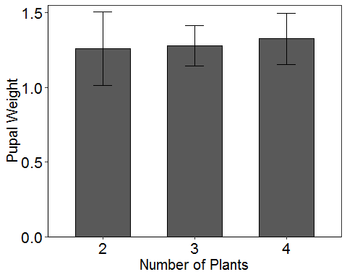

#stats for manuscript  
PWeight=Weight$PWeight  
mean(PWeight)

## [1] 1.288816

sd(PWeight)

## [1] 0.1947783

max(PWeight)

## [1] 1.61

min(PWeight)

## [1] 0.74

getmode <- function(PWeight) {  
 uniqv <- unique(PWeight)  
 uniqv[which.max(tabulate(match(PWeight, uniqv)))]  
}  
  
result<-getmode(PWeight)  
print(result)

## [1] 1.29

### Pupal Duration

PDur<- read.csv("012119_GH2017_ForPdur.csv", header=TRUE)

PDur$Trial=factor(PDur$Trial)  
PDur$Block=factor(PDur$Block)  
PDur$NumPlants=factor(PDur$NumPlants)  
PDur$Year=factor(PDur$Year)  
# Create Year-Block variable with 12 levels  
PDur$YearBlock <- as.numeric(as.factor(paste(PDur$Year, PDur$Block, sep = "-")))  
PDur$YearBlock <- as.factor(PDur$YearBlock)

# Poisson glm

# Poisson glm  
pdur <- glm(PDuration ~ YearBlock + Trial + NumPlants + Trial:NumPlants, data=PDur, family = poisson(link = "log"))  
#not useful, just make sure there isn't a bunch of NA  
summary(pdur)

##   
## Call:  
## glm(formula = PDuration ~ YearBlock + Trial + NumPlants + Trial:NumPlants,   
## family = poisson(link = "log"), data = PDur)  
##   
## Deviance Residuals:   
## Min 1Q Median 3Q Max   
## -1.67017 -0.10419 -0.00306 0.20906 0.55864   
##   
## Coefficients:  
## Estimate Std. Error z value Pr(>|z|)   
## (Intercept) 2.402494 0.128312 18.724 <2e-16 ***  
## YearBlock2 -0.008292 0.094091 -0.088 0.930   
## YearBlock3 -0.003678 0.093376 -0.039 0.969   
## Trial2 -0.124956 0.166909 -0.749 0.454   
## Trial3 -0.170076 0.168930 -1.007 0.314   
## Trial4 -0.164917 0.175788 -0.938 0.348   
## NumPlants3 -0.001474 0.177476 -0.008 0.993   
## NumPlants4 -0.096922 0.195808 -0.495 0.621   
## Trial2:NumPlants3 -0.021786 0.269694 -0.081 0.936   
## Trial3:NumPlants3 -0.106696 0.258967 -0.412 0.680   
## Trial4:NumPlants3 0.055042 0.258930 0.213 0.832   
## Trial2:NumPlants4 0.154739 0.259365 0.597 0.551   
## Trial3:NumPlants4 0.034594 0.266083 0.130 0.897   
## Trial4:NumPlants4 0.084946 0.261239 0.325 0.745   
## ---  
## Signif. codes: 0 '***' 0.001 '**' 0.01 '*' 0.05 '.' 0.1 ' ' 1  
##   
## (Dispersion parameter for poisson family taken to be 1)  
##   
## Null deviance: 11.7837 on 74 degrees of freedom  
## Residual deviance: 7.1172 on 61 degrees of freedom  
## AIC: 343.68  
##   
## Number of Fisher Scoring iterations: 4

# Goodness of fit test with Resids  
Resids <- residuals(pdur, type = "pearson")  
#Change "type" to "deviance" for deviance resids (get the same results)  
plot(fitted(pdur), Resids,  
 xlab = "estimated mean",  
 ylab = "residual",  
 cex.lab = 1.4,  
 pch = 16, col = 4)  
abline(h = 0, lty = 2) #Resids look okay

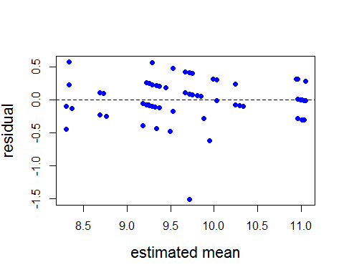

hist(Resids, prob = T)  
lines(density(Resids), col='orange') #Should look like a standard normal - does

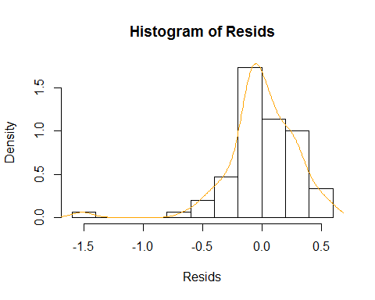

#Using deviance residuals  
#If the p-value is less than 0.05, you have a problem with model fit  
pchisq(deviance(pdur), df.residual(pdur), lower.tail = F)

## [1] 1

#Test for overdispersion  
summary(pdur)$deviance/summary(pdur)$df.residual

## [1] 0.1166754

#0.82 underdispersed by a bit - that's okay (inference is conservative)

# Test for significance of NumPlants  
dtm.emm <- emmeans(pdur, c("NumPlants", "Trial", "YearBlock"), type='response')  
joint_tests(dtm.emm)

## model term df1 df2 F.ratio p.value  
## NumPlants 2 Inf 0.053 0.9485   
## Trial 3 Inf 1.074 0.3585   
## YearBlock 2 Inf 0.004 0.9961   
## NumPlants:Trial 6 Inf 0.150 0.9891

#average by number of plants  
library(plyr)  
ddply(PDur,~NumPlants,summarise,mean=mean(PDuration),sd=sd(PDuration))

## NumPlants mean sd  
## 1 2 9.851852 1.406132  
## 2 3 9.619048 1.283596  
## 3 4 9.481481 0.935224

#Graph for manuscript  
library(lattice)  
library(Rmisc)  
SEPDur<- summarySE(PDur, measurevar="PDuration", groupvars=c("NumPlants"))  
SEPDur

## NumPlants N PDuration sd se ci  
## 1 2 27 9.851852 1.406132 0.2706103 0.5562474  
## 2 3 21 9.619048 1.283596 0.2801036 0.5842860  
## 3 4 27 9.481481 0.935224 0.1799839 0.3699623

library(ggplot2)  
ggplot(SEPDur, aes(x=NumPlants, y=PDuration, width=.6))+  
 geom_bar(stat="identity", color="black",  
 position=position_dodge())+  
 xlab("Number of Plants") +  
 ylab("Pupal Duration (days)")+  
 theme_bw()+  
 geom_errorbar(aes(ymin=PDuration-sd, ymax=PDuration+sd), width=.2,  
 position = position_dodge(.9))+  
 scale_y_continuous(expand=c(0,0), limits=c(0,12.2))+  
 theme(panel.grid.major = element_blank(), panel.grid.minor = element_blank(),  
 panel.background = element_blank(), axis.line = element_line(colour = "black"))+  
 theme(axis.text.x = element_text(size=16))+  
 theme(axis.text.x=element_text(colour="black"))+  
 theme(axis.text.y = element_text(size=16))+  
 theme(axis.text.y=element_text(colour="black"))+  
 theme(axis.title = element_text(size = 15))

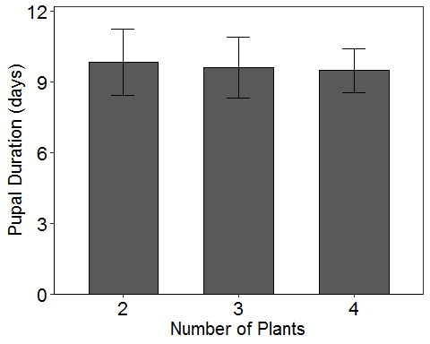

#stats for manuscript  
PDur2=PDur$PDuration  
mean(PDur2)

## [1] 9.653333

sd(PDur2)

## [1] 1.213587

max(PDur2)

## [1] 12

min(PDur2)

## [1] 5

getmode <- function(PDur2) {  
 uniqv <- unique(PDur2)  
 uniqv[which.max(tabulate(match(PDur2, uniqv)))]  
}  
  
result<-getmode(PDur2)  
print(result)

## [1] 10

### Neo to Adult Development

head(PDur)

## Year Trial ID Block NumPlants NeoToAdult PDay PWeight PDuration  
## 1 2017 1 1 1 4 24 13 1.55 11  
## 2 2017 1 2 1 3 21 11 1.31 10  
## 3 2017 1 3 1 2 24 13 1.07 12  
## 4 2017 1 4 1 3 22 11 1.15 11  
## 5 2017 1 5 1 4 24 14 1.13 10  
## 6 2017 1 9 1 2 24 13 1.32 11  
## InstarToMove DaysToMove TimesMoved Move1st Move2nd Move3rd Move4th  
## 1 4 7 5 0 0 0 2  
## 2 4 7 3 0 0 0 2  
## 3 4 8 4 0 0 0 1  
## 4 4 6 4 0 0 0 1  
## 5 4 7 6 0 0 0 2  
## 6 4 7 4 0 0 0 1  
## Move5th PlantAbandonment Abandon1st Abandon2nd Abandon3rd Abandon4th  
## 1 3 4 0 0 0 2  
## 2 1 2 0 0 0 1  
## 3 3 3 0 0 0 1  
## 4 3 3 0 0 0 1  
## 5 4 5 0 0 0 2  
## 6 3 3 0 0 0 1  
## Abandon5th NumPlantsVisited PercPlantsVisited ObsOnPlant ObsOnCage  
## 1 2 4 100.00000 22 3  
## 2 1 1 33.33333 20 3  
## 3 2 2 100.00000 23 3  
## 4 2 2 66.66667 18 5  
## 5 3 4 100.00000 26 3  
## 6 2 2 100.00000 20 6  
## YearBlock  
## 1 1  
## 2 1  
## 3 1  
## 4 1  
## 5 1  
## 6 1

# Poisson glm

# Poisson glm  
neo <- glm(NeoToAdult ~ YearBlock + Trial + NumPlants + Trial:NumPlants, data=PDur, family = poisson(link = "log"))  
#not useful, just make sure there isn't a bunch of NA  
summary(neo)

##   
## Call:  
## glm(formula = NeoToAdult ~ YearBlock + Trial + NumPlants + Trial:NumPlants,   
## family = poisson(link = "log"), data = PDur)  
##   
## Deviance Residuals:   
## Min 1Q Median 3Q Max   
## -1.15296 -0.15016 -0.05194 0.12068 0.97873   
##   
## Coefficients:  
## Estimate Std. Error z value Pr(>|z|)   
## (Intercept) 3.180446 0.086902 36.598 <2e-16 ***  
## YearBlock2 -0.005619 0.063087 -0.089 0.9290   
## YearBlock3 -0.020959 0.062954 -0.333 0.7392   
## Trial2 -0.111864 0.113025 -0.990 0.3223   
## Trial3 -0.203156 0.115828 -1.754 0.0794 .   
## Trial4 -0.058110 0.115851 -0.502 0.6160   
## NumPlants3 -0.044224 0.122105 -0.362 0.7172   
## NumPlants4 -0.016838 0.129564 -0.130 0.8966   
## Trial2:NumPlants3 0.084592 0.181530 0.466 0.6412   
## Trial3:NumPlants3 -0.015525 0.177301 -0.088 0.9302   
## Trial4:NumPlants3 0.037731 0.173543 0.217 0.8279   
## Trial2:NumPlants4 0.047661 0.173620 0.275 0.7837   
## Trial3:NumPlants4 -0.019811 0.179119 -0.111 0.9119   
## Trial4:NumPlants4 -0.073546 0.172045 -0.427 0.6690   
## ---  
## Signif. codes: 0 '***' 0.001 '**' 0.01 '*' 0.05 '.' 0.1 ' ' 1  
##   
## (Dispersion parameter for poisson family taken to be 1)  
##   
## Null deviance: 20.5402 on 74 degrees of freedom  
## Residual deviance: 9.6165 on 61 degrees of freedom  
## AIC: 405  
##   
## Number of Fisher Scoring iterations: 4

# Goodness of fit test with Resids  
Resids <- residuals(neo, type = "pearson")  
#Change "type" to "deviance" for deviance resids (get the same results)  
plot(fitted(neo), Resids,  
 xlab = "estimated mean",  
 ylab = "residual",  
 cex.lab = 1.4,  
 pch = 16, col = 4)  
abline(h = 0, lty = 2) #Resids look okay

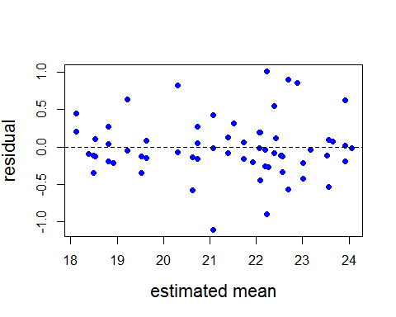

hist(Resids, prob = T)  
lines(density(Resids), col='orange') #Should look like a standard normal - does

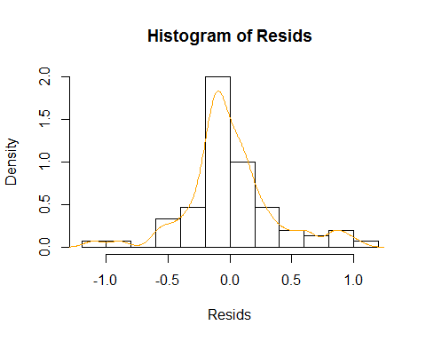

#Using deviance residuals  
#If the p-value is less than 0.05, you have a problem with model fit  
pchisq(deviance(neo), df.residual(neo), lower.tail = F)

## [1] 1

#Test for overdispersion  
summary(neo)$deviance/summary(neo)$df.residual

## [1] 0.1576474

#0.82 underdispersed by a bit - that's okay (inference is conservative)

# Test for significance of NumPlants  
dtm.emm <- emmeans(neo, c("NumPlants", "Trial", "YearBlock"), type='response')  
joint_tests(dtm.emm)

## model term df1 df2 F.ratio p.value  
## NumPlants 2 Inf 0.113 0.8929   
## Trial 3 Inf 2.989 0.0297   
## YearBlock 2 Inf 0.061 0.9409   
## NumPlants:Trial 6 Inf 0.169 0.9850

#average by number of plants  
library(plyr)  
ddply(PDur,~NumPlants,summarise,mean=mean(NeoToAdult),sd=sd(NeoToAdult))

## NumPlants mean sd  
## 1 2 21.74074 2.836474  
## 2 3 21.28571 2.452404  
## 3 4 20.88889 1.967688

#Graph for manuscript  
library(lattice)  
library(Rmisc)  
SEPDur<- summarySE(PDur, measurevar="NeoToAdult", groupvars=c("NumPlants"))  
SEPDur

## NumPlants N NeoToAdult sd se ci  
## 1 2 27 21.74074 2.836474 0.5458797 1.1220717  
## 2 3 21 21.28571 2.452404 0.5351584 1.1163209  
## 3 4 27 20.88889 1.967688 0.3786817 0.7783913

library(ggplot2)  
ggplot(SEPDur, aes(x=NumPlants, y=NeoToAdult, width=.6))+  
 geom_bar(stat="identity", color="black",  
 position=position_dodge())+  
 xlab("Number of Plants") +  
 ylab("Duration of Neonate to Adult Eclosion (days)")+  
 theme_bw()+  
 geom_errorbar(aes(ymin=NeoToAdult-sd, ymax=NeoToAdult+sd), width=.2,  
 position = position_dodge(.9))+  
 scale_y_continuous(expand=c(0,0), limits=c(0,25.4))+  
 theme(panel.grid.major = element_blank(), panel.grid.minor = element_blank(),  
 panel.background = element_blank(), axis.line = element_line(colour = "black"))+  
 theme(axis.text.x = element_text(size=16))+  
 theme(axis.text.x=element_text(colour="black"))+  
 theme(axis.text.y = element_text(size=16))+  
 theme(axis.text.y=element_text(colour="black"))+  
 theme(axis.title = element_text(size = 15))

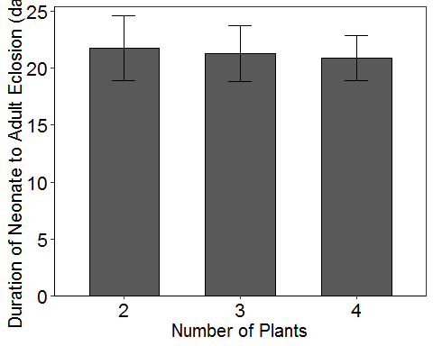

#stats for manuscript  
Neo=PDur$NeoToAdult  
mean(Neo)

## [1] 21.30667

sd(Neo)

## [1] 2.438283

max(Neo)

## [1] 27

min(Neo)

## [1] 16

getmode <- function(Neo) {  
 uniqv <- unique(Neo)  
 uniqv[which.max(tabulate(match(Neo, uniqv)))]  
}  
  
result<-getmode(Neo)  
print(result)

## [1] 22

### Only 2018 Data

### Biomass Consumed by Instar at Abandonment

Bio<-read.csv("012219_GH18_BiomassByInstar_NatalStem.csv", header=TRUE)

Bio$Trial=factor(Bio$Trial)  
Bio$Block=factor(Bio$Block)  
Bio$NumPlants=factor(Bio$NumPlants)  
Bio$Year=factor(Bio$Year)  
# Create Year-Block variable with 12 levels  
Bio$YearBlock <- as.numeric(as.factor(paste(Bio$Year, Bio$Block, sep = "-")))  
Bio$YearBlock <- as.factor(Bio$YearBlock)  
Bio$MoveInstar <- as.factor(Bio$MoveInstar)  
Bio$Biomass <- as.numeric(Bio$Biomass)

head(Bio)

## Year Trial ID Block NumPlants MoveInstar Biomass YearBlock  
## 1 2018 5 1 1 2 4 72.98344 1  
## 2 2018 5 2 1 4 5 809.95984 1  
## 3 2018 5 5 1 4 4 40.07061 1  
## 4 2018 5 6 1 2 5 923.01816 1  
## 5 2018 5 7 1 3 4 109.85084 1  
## 6 2018 5 8 1 3 4 127.35669 1

# Poisson glm

# Poisson glm  
biomass <- glm(Biomass ~ YearBlock + Trial + NumPlants + MoveInstar + Trial:NumPlants, data=Bio, family = poisson(link = "log"))

## Warning in dpois(y, mu, log = TRUE): non-integer x = 72.983439

## Warning in dpois(y, mu, log = TRUE): non-integer x = 809.959841

## Warning in dpois(y, mu, log = TRUE): non-integer x = 40.070606

## Warning in dpois(y, mu, log = TRUE): non-integer x = 923.018157

## Warning in dpois(y, mu, log = TRUE): non-integer x = 109.850837

## Warning in dpois(y, mu, log = TRUE): non-integer x = 127.356687

## Warning in dpois(y, mu, log = TRUE): non-integer x = 66.581714

## Warning in dpois(y, mu, log = TRUE): non-integer x = 204.682095

## Warning in dpois(y, mu, log = TRUE): non-integer x = 1390.627127

## Warning in dpois(y, mu, log = TRUE): non-integer x = 172.249355

## Warning in dpois(y, mu, log = TRUE): non-integer x = 675.433612

## Warning in dpois(y, mu, log = TRUE): non-integer x = 146.118824

## Warning in dpois(y, mu, log = TRUE): non-integer x = 40.156341

## Warning in dpois(y, mu, log = TRUE): non-integer x = 1689.136949

## Warning in dpois(y, mu, log = TRUE): non-integer x = 5.299849

## Warning in dpois(y, mu, log = TRUE): non-integer x = 798.905322

## Warning in dpois(y, mu, log = TRUE): non-integer x = 152.080612

## Warning in dpois(y, mu, log = TRUE): non-integer x = 171.486175

## Warning in dpois(y, mu, log = TRUE): non-integer x = 65.205071

## Warning in dpois(y, mu, log = TRUE): non-integer x = 158.736617

## Warning in dpois(y, mu, log = TRUE): non-integer x = 67.812420

## Warning in dpois(y, mu, log = TRUE): non-integer x = 30.818178

## Warning in dpois(y, mu, log = TRUE): non-integer x = 74.622535

## Warning in dpois(y, mu, log = TRUE): non-integer x = 12.151211

## Warning in dpois(y, mu, log = TRUE): non-integer x = 11.581706

## Warning in dpois(y, mu, log = TRUE): non-integer x = 28.087481

## Warning in dpois(y, mu, log = TRUE): non-integer x = 531.876048

## Warning in dpois(y, mu, log = TRUE): non-integer x = 91.871861

## Warning in dpois(y, mu, log = TRUE): non-integer x = 11.145014

## Warning in dpois(y, mu, log = TRUE): non-integer x = 69.531921

## Warning in dpois(y, mu, log = TRUE): non-integer x = 52.227525

## Warning in dpois(y, mu, log = TRUE): non-integer x = 31.194043

## Warning in dpois(y, mu, log = TRUE): non-integer x = 45.237518

## Warning in dpois(y, mu, log = TRUE): non-integer x = 9.959226

## Warning in dpois(y, mu, log = TRUE): non-integer x = 3.424619

## Warning in dpois(y, mu, log = TRUE): non-integer x = 16.912504

## Warning in dpois(y, mu, log = TRUE): non-integer x = 154.772415

## Warning in dpois(y, mu, log = TRUE): non-integer x = 103.581672

## Warning in dpois(y, mu, log = TRUE): non-integer x = 170.033656

## Warning in dpois(y, mu, log = TRUE): non-integer x = 8.111352

## Warning in dpois(y, mu, log = TRUE): non-integer x = 38.769702

## Warning in dpois(y, mu, log = TRUE): non-integer x = 9.620835

## Warning in dpois(y, mu, log = TRUE): non-integer x = 14.109604

## Warning in dpois(y, mu, log = TRUE): non-integer x = 20.834252

## Warning in dpois(y, mu, log = TRUE): non-integer x = 23.707551

## Warning in dpois(y, mu, log = TRUE): non-integer x = 31.245577

## Warning in dpois(y, mu, log = TRUE): non-integer x = 13.362152

## Warning in dpois(y, mu, log = TRUE): non-integer x = 88.973731

## Warning in dpois(y, mu, log = TRUE): non-integer x = 9.963736

## Warning in dpois(y, mu, log = TRUE): non-integer x = 18.568354

## Warning in dpois(y, mu, log = TRUE): non-integer x = 31.739959

## Warning in dpois(y, mu, log = TRUE): non-integer x = 81.709037

## Warning in dpois(y, mu, log = TRUE): non-integer x = 56.985791

## Warning in dpois(y, mu, log = TRUE): non-integer x = 47.562077

## Warning in dpois(y, mu, log = TRUE): non-integer x = 19.502437

## Warning in dpois(y, mu, log = TRUE): non-integer x = 21.080322

## Warning in dpois(y, mu, log = TRUE): non-integer x = 47.486259

## Warning in dpois(y, mu, log = TRUE): non-integer x = 133.635629

## Warning in dpois(y, mu, log = TRUE): non-integer x = 2.016720

## Warning in dpois(y, mu, log = TRUE): non-integer x = 3.185204

## Warning in dpois(y, mu, log = TRUE): non-integer x = 133.583862

## Warning in dpois(y, mu, log = TRUE): non-integer x = 1232.930285

## Warning in dpois(y, mu, log = TRUE): non-integer x = 196.911433

## Warning in dpois(y, mu, log = TRUE): non-integer x = 93.559733

## Warning in dpois(y, mu, log = TRUE): non-integer x = 53.282502

## Warning in dpois(y, mu, log = TRUE): non-integer x = 35.323204

## Warning in dpois(y, mu, log = TRUE): non-integer x = 35.482156

## Warning in dpois(y, mu, log = TRUE): non-integer x = 76.193836

## Warning in dpois(y, mu, log = TRUE): non-integer x = 106.129615

## Warning in dpois(y, mu, log = TRUE): non-integer x = 45.494671

## Warning in dpois(y, mu, log = TRUE): non-integer x = 121.989966

#not useful, just make sure there isn't a bunch of NA  
summary(biomass)

##   
## Call:  
## glm(formula = Biomass ~ YearBlock + Trial + NumPlants + MoveInstar +   
## Trial:NumPlants, family = poisson(link = "log"), data = Bio)  
##   
## Deviance Residuals:   
## Min 1Q Median 3Q Max   
## -25.9165 -3.1187 0.4831 2.3001 21.3638   
##   
## Coefficients:  
## Estimate Std. Error z value Pr(>|z|)   
## (Intercept) 2.85906 0.12134 23.562 < 2e-16 ***  
## YearBlock2 0.34794 0.02761 12.601 < 2e-16 ***  
## YearBlock3 0.12427 0.02555 4.864 1.15e-06 ***  
## YearBlock4 -0.21234 0.03893 -5.454 4.92e-08 ***  
## YearBlock5 0.65768 0.06000 10.961 < 2e-16 ***  
## YearBlock6 0.08197 0.06222 1.317 0.187718   
## YearBlock7 -0.77921 0.09794 -7.956 1.78e-15 ***  
## YearBlock8 0.34815 0.09603 3.625 0.000289 ***  
## YearBlock9 0.54463 0.06801 8.008 1.16e-15 ***  
## Trial6 -1.11992 0.05174 -21.646 < 2e-16 ***  
## Trial7 -0.50457 0.05228 -9.650 < 2e-16 ***  
## NumPlants3 -0.49771 0.04847 -10.268 < 2e-16 ***  
## NumPlants4 -0.27603 0.02570 -10.742 < 2e-16 ***  
## MoveInstar3 1.09261 0.13346 8.187 2.69e-16 ***  
## MoveInstar4 2.19644 0.12021 18.271 < 2e-16 ***  
## MoveInstar5 3.87962 0.12051 32.192 < 2e-16 ***  
## Trial6:NumPlants3 0.45284 0.07311 6.194 5.87e-10 ***  
## Trial7:NumPlants3 1.31950 0.07902 16.699 < 2e-16 ***  
## Trial6:NumPlants4 0.43477 0.05790 7.509 5.94e-14 ***  
## Trial7:NumPlants4 -0.14733 0.08932 -1.649 0.099055 .   
## ---  
## Signif. codes: 0 '***' 0.001 '**' 0.01 '*' 0.05 '.' 0.1 ' ' 1  
##   
## (Dispersion parameter for poisson family taken to be 1)  
##   
## Null deviance: 26443.8 on 73 degrees of freedom  
## Residual deviance: 3549.7 on 54 degrees of freedom  
## AIC: Inf  
##   
## Number of Fisher Scoring iterations: 5

# Goodness of fit test with Resids  
Resids <- residuals(biomass, type = "pearson")  
#Change "type" to "deviance" for deviance resids (get the same results)  
plot(fitted(biomass), Resids,  
 xlab = "estimated mean",  
 ylab = "residual",  
 cex.lab = 1.4,  
 pch = 16, col = 4)  
abline(h = 0, lty = 2) #Resids look okay

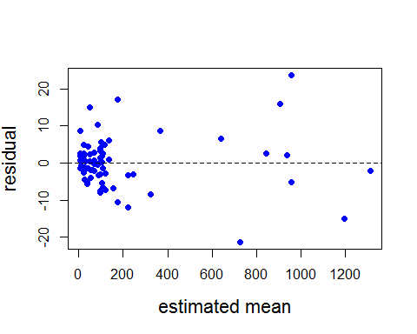

hist(Resids, prob = T)  
lines(density(Resids), col='orange') #Should look like a standard normal - does

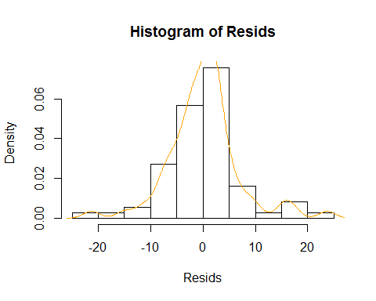

#Using deviance residuals  
#If the p-value is less than 0.05, you have a problem with model fit  
pchisq(deviance(biomass), df.residual(biomass), lower.tail = F)

## [1] 0

### Leaves Consumed by Instar at Abandonment

## wait to hear from Audrey

### On Stem Movement by Instar

## wait to hear from Audrey

### Only 2017 Data

### Among Plant Movements

GH1718<- read.csv("011819_GH2017&2018_FullDevelopment_ForAnalysis.csv")

GH1718$Trial=factor(GH1718$Trial)  
GH1718$Block=factor(GH1718$Block)  
GH1718$NumPlants=factor(GH1718$NumPlants)  
GH1718$Year=factor(GH1718$Year)  
GH1718$YearBlock <- as.numeric(as.factor(paste(GH1718$Year, GH1718$Block, sep = "-")))  
GH1718$YearBlock <- as.factor(GH1718$YearBlock)

#Reduce data frame  
GH1718.complete <- GH1718[which(GH1718$Trial == 1 | GH1718$Trial == 2 | GH1718$Trial == 3 | GH1718$Trial == 4),]  
nrow(GH1718)

## [1] 102

nrow(GH1718.complete)

## [1] 77

head(GH1718.complete)

## Year Trial ID Block NumPlants PDay PWeight InstarToMove DaysToMove  
## 1 2017 1 1 1 4 13 1.55 4 7  
## 2 2017 1 2 1 3 11 1.31 4 7  
## 3 2017 1 3 1 2 13 1.07 4 8  
## 4 2017 1 4 1 3 11 1.15 4 6  
## 5 2017 1 5 1 4 14 1.13 4 7  
## 6 2017 1 9 1 2 13 1.32 4 7  
## TimesMoved Move1st Move2nd Move3rd Move4th Move5th PlantAbandonment  
## 1 5 0 0 0 2 3 4  
## 2 3 0 0 0 2 1 2  
## 3 4 0 0 0 1 3 3  
## 4 4 0 0 0 1 3 3  
## 5 6 0 0 0 2 4 5  
## 6 4 0 0 0 1 3 3  
## Abandon1st Abandon2nd Abandon3rd Abandon4th Abandon5th NumPlantsVisited  
## 1 0 0 0 2 2 4  
## 2 0 0 0 1 1 1  
## 3 0 0 0 1 2 2  
## 4 0 0 0 1 2 2  
## 5 0 0 0 2 3 4  
## 6 0 0 0 1 2 2  
## PercPlantsVisited PercPlantArcSine ObsOnPlant ObsOnCage TimesObs  
## 1 100.00000 1.5707963 22 3 25  
## 2 33.33333 0.6154797 20 3 23  
## 3 100.00000 1.5707963 23 3 26  
## 4 66.66667 0.9553166 18 5 23  
## 5 100.00000 1.5707963 26 3 29  
## 6 100.00000 1.5707963 20 6 26  
## RelPlant RelCage PlantArcSine CageArcSine YearBlock  
## 1 0.8800000 0.1200000 1.217055 0.3537416 1  
## 2 0.8695652 0.1304348 1.201287 0.3695089 1  
## 3 0.8846154 0.1153846 1.224216 0.3465800 1  
## 4 0.7826087 0.2173913 1.085747 0.4850498 1  
## 5 0.8965517 0.1034483 1.243342 0.3274544 1  
## 6 0.7692308 0.2307692 1.069703 0.5010930 1

# Poisson glm

# Poisson glm  
among <- glm(TimesMoved ~ YearBlock + Trial + NumPlants + Trial:NumPlants, data=PDur, family = poisson(link = "log"))  
#not useful, just make sure there isn't a bunch of NA  
summary(among)

##   
## Call:  
## glm(formula = TimesMoved ~ YearBlock + Trial + NumPlants + Trial:NumPlants,   
## family = poisson(link = "log"), data = PDur)  
##   
## Deviance Residuals:   
## Min 1Q Median 3Q Max   
## -2.03262 -0.62807 0.00009 0.58836 2.00790   
##   
## Coefficients:  
## Estimate Std. Error z value Pr(>|z|)   
## (Intercept) 1.274507 0.219500 5.806 6.38e-09 ***  
## YearBlock2 0.033381 0.155524 0.215 0.830   
## YearBlock3 0.080174 0.152132 0.527 0.598   
## Trial2 0.169100 0.266790 0.634 0.526   
## Trial3 -0.269155 0.298193 -0.903 0.367   
## Trial4 -0.013618 0.289950 -0.047 0.963   
## NumPlants3 0.254716 0.284637 0.895 0.371   
## NumPlants4 0.082855 0.319207 0.260 0.795   
## Trial2:NumPlants3 -0.405499 0.424919 -0.954 0.340   
## Trial3:NumPlants3 -0.199849 0.432534 -0.462 0.644   
## Trial4:NumPlants3 -0.355455 0.422388 -0.842 0.400   
## Trial2:NumPlants4 -0.331997 0.420400 -0.790 0.430   
## Trial3:NumPlants4 -0.192843 0.457391 -0.422 0.673   
## Trial4:NumPlants4 0.004157 0.418480 0.010 0.992   
## ---  
## Signif. codes: 0 '***' 0.001 '**' 0.01 '*' 0.05 '.' 0.1 ' ' 1  
##   
## (Dispersion parameter for poisson family taken to be 1)  
##   
## Null deviance: 61.569 on 74 degrees of freedom  
## Residual deviance: 53.360 on 61 degrees of freedom  
## AIC: 310.3  
##   
## Number of Fisher Scoring iterations: 5

# Goodness of fit test with Resids  
Resids <- residuals(among, type = "pearson")  
#Change "type" to "deviance" for deviance resids (get the same results)  
plot(fitted(among), Resids,  
 xlab = "estimated mean",  
 ylab = "residual",  
 cex.lab = 1.4,  
 pch = 16, col = 4)  
abline(h = 0, lty = 2) #Resids look okay

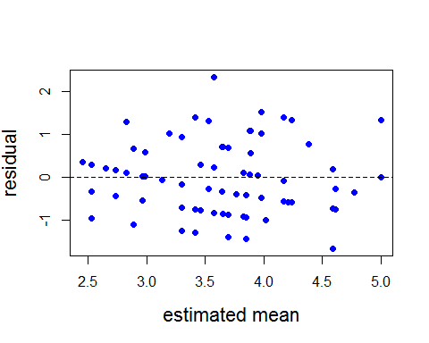

hist(Resids, prob = T)  
lines(density(Resids), col='orange') #Should look like a standard normal - does

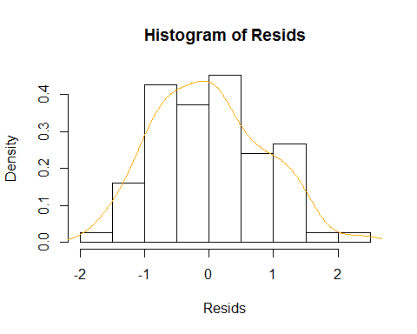

#Using deviance residuals  
#If the p-value is less than 0.05, you have a problem with model fit  
pchisq(deviance(among), df.residual(among), lower.tail = F)

## [1] 0.7459545

#Test for overdispersion  
summary(among)$deviance/summary(among)$df.residual

## [1] 0.8747562

#0.82 underdispersed by a bit - that's okay (inference is conservative)

# Test for significance of NumPlants  
dtm.emm <- emmeans(among, c("NumPlants", "Trial", "YearBlock"), type='response')  
joint_tests(dtm.emm)

## model term df1 df2 F.ratio p.value  
## NumPlants 2 Inf 0.086 0.9173   
## Trial 3 Inf 1.740 0.1564   
## YearBlock 2 Inf 0.142 0.8673   
## NumPlants:Trial 6 Inf 0.371 0.8977

#Graph for manuscript  
library(lattice)  
library(Rmisc)  
SEamong<- summarySE(GH1718.complete, measurevar="TimesMoved", groupvars=c("NumPlants"))  
SEamong

## NumPlants N TimesMoved sd se ci  
## 1 2 29 3.689655 1.713464 0.3181824 0.6517670  
## 2 3 21 3.666667 1.527525 0.3333333 0.6953211  
## 3 4 27 3.481481 1.968412 0.3788210 0.7786777

library(ggplot2)  
ggplot(SEamong, aes(x=NumPlants, y=TimesMoved, width=.6))+  
 geom_bar(stat="identity", color="black",  
 position=position_dodge())+  
 xlab("Number of Plants") +  
 ylab("Total Among Plant Movements")+  
 theme_bw()+  
 geom_errorbar(aes(ymin=TimesMoved-sd, ymax=TimesMoved+sd), width=.2,  
 position = position_dodge(.9))+  
 scale_y_continuous(expand=c(0,0), limits=c(0,6.2))+  
 theme(panel.grid.major = element_blank(), panel.grid.minor = element_blank(),  
 panel.background = element_blank(), axis.line = element_line(colour = "black"))+  
 theme(axis.text.x = element_text(size=16))+  
 theme(axis.text.x=element_text(colour="black"))+  
 theme(axis.text.y = element_text(size=16))+  
 theme(axis.text.y=element_text(colour="black"))+  
 theme(axis.title = element_text(size = 15))

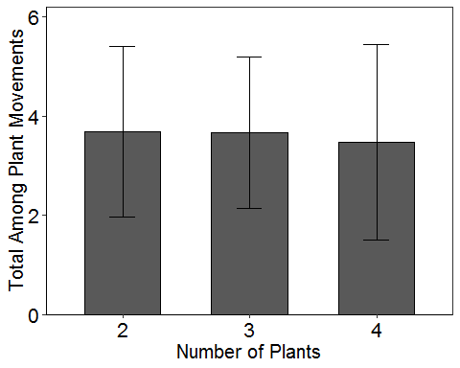

#stats for manuscript  
among2=GH1718.complete$TimesMoved  
length(among2)

## [1] 77

mean(among2)

## [1] 3.61039

sd(among2)

## [1] 1.740809

max(among2)

## [1] 8

min(among2)

## [1] 1

getmode <- function(among2) {  
 uniqv <- unique(among2)  
 uniqv[which.max(tabulate(match(among2, uniqv)))]  
}  
  
result<-getmode(among2)  
print(result)

## [1] 3

### Total Plant Abandonments

# Poisson glm

# Poisson glm  
aban <- glm(PlantAbandonment ~ YearBlock + Trial + NumPlants + Trial:NumPlants, data=PDur, family = poisson(link = "log"))  
#not useful, just make sure there isn't a bunch of NA  
summary(aban)

##   
## Call:  
## glm(formula = PlantAbandonment ~ YearBlock + Trial + NumPlants +   
## Trial:NumPlants, family = poisson(link = "log"), data = PDur)  
##   
## Deviance Residuals:   
## Min 1Q Median 3Q Max   
## -1.5782 -0.3621 -0.1289 0.4311 1.3236   
##   
## Coefficients:  
## Estimate Std. Error z value Pr(>|z|)   
## (Intercept) 1.17211 0.23480 4.992 5.98e-07 ***  
## YearBlock2 0.02337 0.17067 0.137 0.891   
## YearBlock3 0.02590 0.16944 0.153 0.879   
## Trial2 -0.09134 0.30274 -0.302 0.763   
## Trial3 -0.36327 0.32639 -1.113 0.266   
## Trial4 -0.08999 0.31500 -0.286 0.775   
## NumPlants3 -0.02407 0.32722 -0.074 0.941   
## NumPlants4 0.06826 0.34068 0.200 0.841   
## Trial2:NumPlants3 0.10956 0.48202 0.227 0.820   
## Trial3:NumPlants3 0.11503 0.48668 0.236 0.813   
## Trial4:NumPlants3 -0.03696 0.47314 -0.078 0.938   
## Trial2:NumPlants4 -0.22205 0.46942 -0.473 0.636   
## Trial3:NumPlants4 -0.01095 0.48948 -0.022 0.982   
## Trial4:NumPlants4 0.10164 0.45041 0.226 0.821   
## ---  
## Signif. codes: 0 '***' 0.001 '**' 0.01 '*' 0.05 '.' 0.1 ' ' 1  
##   
## (Dispersion parameter for poisson family taken to be 1)  
##   
## Null deviance: 36.849 on 74 degrees of freedom  
## Residual deviance: 32.261 on 61 degrees of freedom  
## AIC: 276.97  
##   
## Number of Fisher Scoring iterations: 4

# Goodness of fit test with Resids  
Resids <- residuals(aban, type = "pearson")  
#Change "type" to "deviance" for deviance resids (get the same results)  
plot(fitted(aban), Resids,  
 xlab = "estimated mean",  
 ylab = "residual",  
 cex.lab = 1.4,  
 pch = 16, col = 4)  
abline(h = 0, lty = 2) #Resids look okay

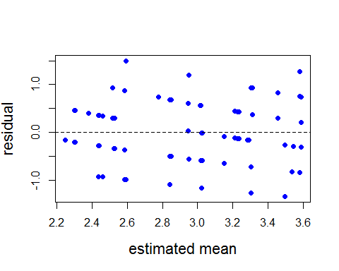

hist(Resids, prob = T)  
lines(density(Resids), col='orange') #Should look like a standard normal - does

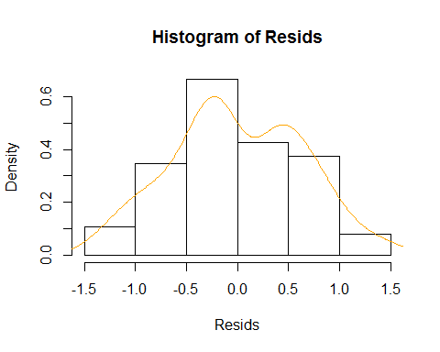

#Using deviance residuals  
#If the p-value is less than 0.05, you have a problem with model fit  
pchisq(deviance(aban), df.residual(aban), lower.tail = F)

## [1] 0.999089

#Test for overdispersion  
summary(aban)$deviance/summary(aban)$df.residual

## [1] 0.5288675

#0.82 underdispersed by a bit - that's okay (inference is conservative)

# Test for significance of NumPlants  
dtm.emm <- emmeans(aban, c("NumPlants", "Trial", "YearBlock"), type='response')  
joint_tests(dtm.emm)

## model term df1 df2 F.ratio p.value  
## NumPlants 2 Inf 0.024 0.9761   
## Trial 3 Inf 0.984 0.3989   
## YearBlock 2 Inf 0.014 0.9863   
## NumPlants:Trial 6 Inf 0.199 0.9772

#Graph for manuscript  
library(lattice)  
library(Rmisc)  
SEaban<- summarySE(GH1718.complete, measurevar="PlantAbandonment", groupvars=c("NumPlants"))  
SEaban

## NumPlants N PlantAbandonment sd se ci  
## 1 2 29 2.896552 1.1447029 0.2125660 0.4354217  
## 2 3 21 2.904762 0.9952267 0.2171763 0.4530218  
## 3 4 27 2.925926 1.4391751 0.2769694 0.5693187

library(ggplot2)  
ggplot(SEaban, aes(x=NumPlants, y=PlantAbandonment, width=.6))+  
 geom_bar(stat="identity", color="black",  
 position=position_dodge())+  
 xlab("Number of Plants") +  
 ylab("Total Plant Abandonments")+  
 theme_bw()+  
 geom_errorbar(aes(ymin=PlantAbandonment-sd, ymax=PlantAbandonment+sd), width=.2,  
 position = position_dodge(.9))+  
 scale_y_continuous(expand=c(0,0), limits=c(0,5.2))+  
 theme(panel.grid.major = element_blank(), panel.grid.minor = element_blank(),  
 panel.background = element_blank(), axis.line = element_line(colour = "black"))+  
 theme(axis.text.x = element_text(size=16))+  
 theme(axis.text.x=element_text(colour="black"))+  
 theme(axis.text.y = element_text(size=16))+  
 theme(axis.text.y=element_text(colour="black"))+  
 theme(axis.title = element_text(size = 15))

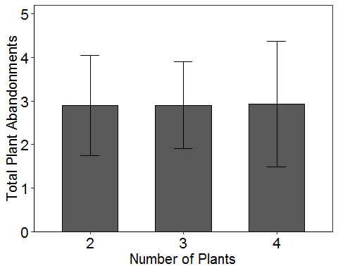

#stats for manuscript  
aban2=GH1718.complete$PlantAbandonment  
length(aban2)

## [1] 77

mean(aban2)

## [1] 2.909091

sd(aban2)

## [1] 1.205053

max(aban2)

## [1] 6

min(aban2)

## [1] 1

getmode <- function(aban2) {  
 uniqv <- unique(aban2)  
 uniqv[which.max(tabulate(match(aban2, uniqv)))]  
}  
  
result<-getmode(aban2)  
print(result)

## [1] 2

### Abandonment by Instar

## wait to hear from Audrey

### Among Plant Movements by Instar

## wait to hear from Audrey